Amazon | OA 2020 | Throttling Gateway

LEETCODE :

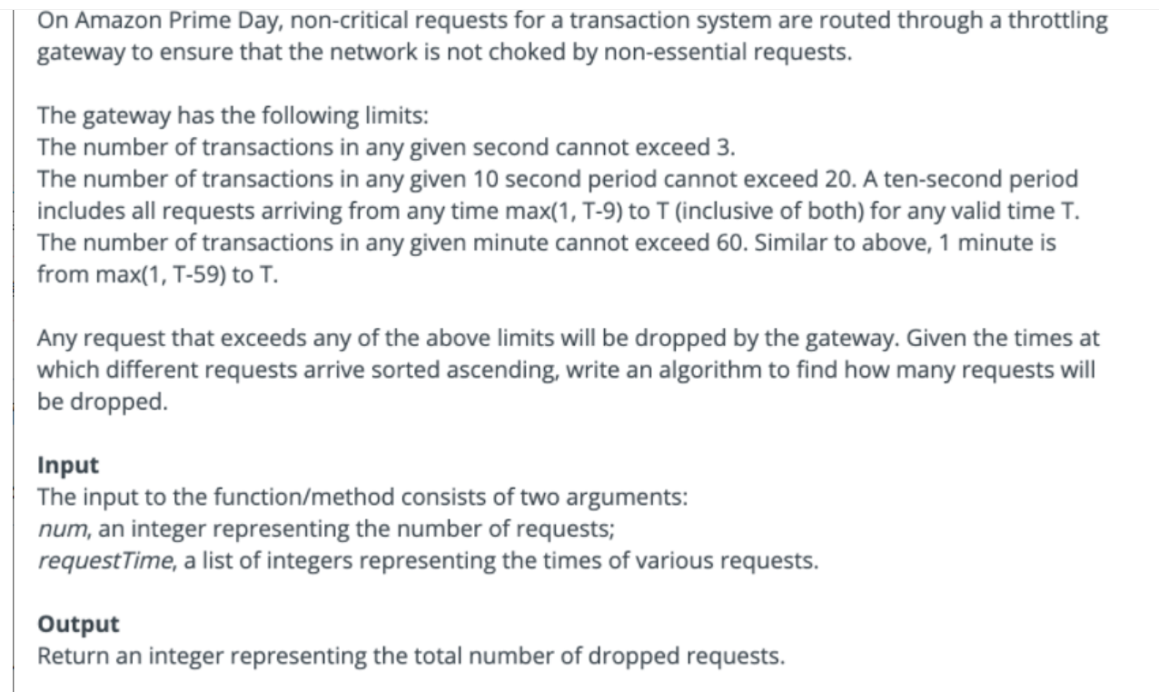

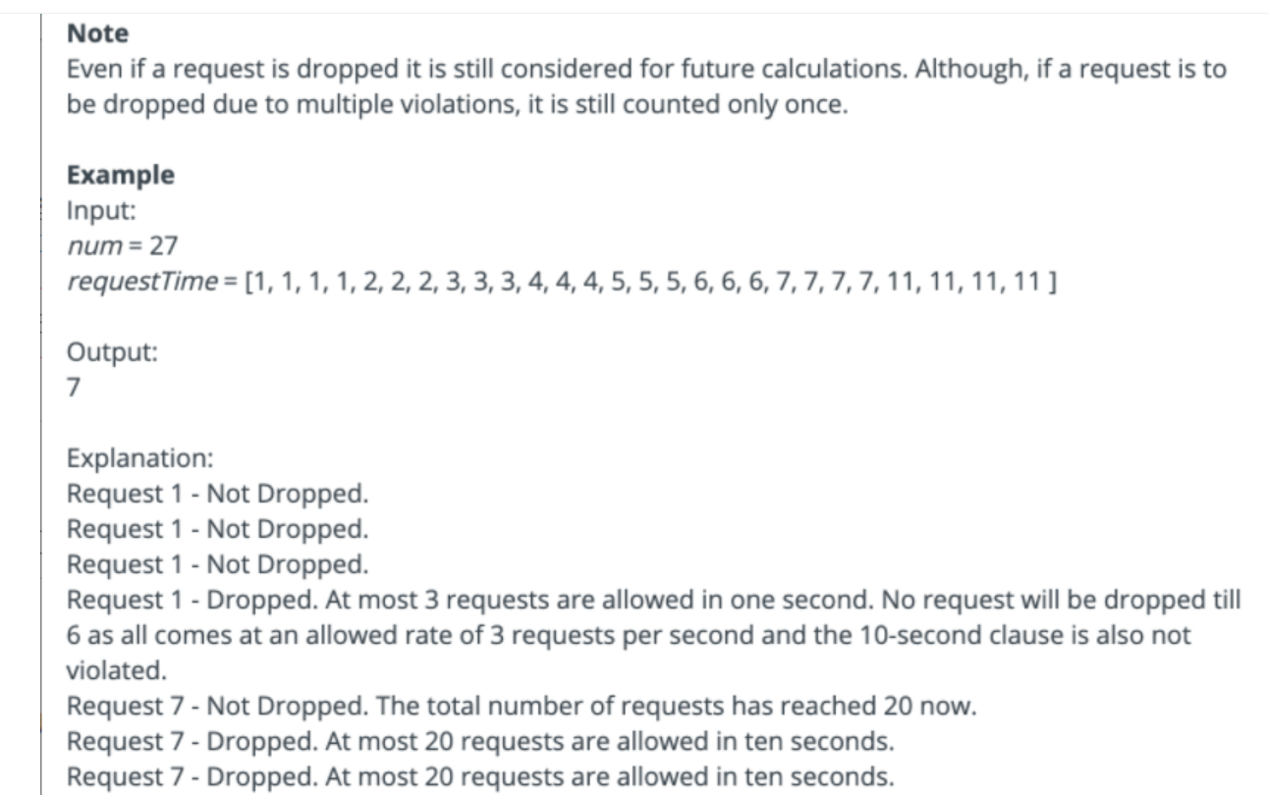

import java.util.\*;

public class Solution {

public static int solve(int[] arr) {

List<Integer> indCount = new ArrayList<>();

List<Integer> aggCount = new ArrayList<>();

indCount.add(0);

aggCount.add(0);

int droppedCount = 0;

for(int i=0;i<arr.length;i++)

{

int a = arr[i];

if(a+1>indCount.size())

{

if(a+1 > indCount.size()+1)

{

for(int k=indCount.size();k<a;k++)

{

indCount.add(0);

aggCount.add(aggCount.get(k-1));

}

}

indCount.add(1);

aggCount.add(1+aggCount.get(a-1));

}

else{

indCount.set(a,indCount.get(a)+1);

aggCount.set(a,aggCount.get(a)+1);

}

if(indCount.get(a)>3)

{

droppedCount++;

continue;

}

if(a>=10)

{

if(aggCount.get(a)-aggCount.get(a-10)>20)

{

droppedCount++;

continue;

}

}

else

{

if(aggCount.get(a)>20)

{

droppedCount++;

continue;

}

}

if(a>=60)

{

if(aggCount.get(a)-aggCount.get(a-60)>60)

{

droppedCount++;

}

}

else

{

if(aggCount.get(a)>60)

{

droppedCount++;

}

}

}

return droppedCount;

}

}